1.In the Search box type bigtable and choose the Bigtable option from the list & click on Create Instance

(create instance is restricred when you do the lab, you can choose the existing instance to complete the activity, the below steps are for your understanding only no need to do it)

3. Select storage type as SSD for the instance

4.Configure the cluster, clusterID will be autogenerated choose region and zone for the cluster

5. Provide the nodes for the node, the nodes can be given through manual allocation and autoscaling

6. Click on the bigtable instance

7. You can create tables by clicking the Tables option, with Bigtable Studio you can write queries to fetch the data. Backup for the instance can be managed using the Backups option.

8.Click on Activate Cloud Shell to manage tables using CBT commands.

9.To manage the tables using CBT commands, you need to add the project name and instance name in cbtrc file.

Use the below commands to create and add values to the big table instance

Using Cbt:

---------

echo project=acn-cloud-capability>~/.cbtrc

echo instance=trg-demo-14feb>~/.cbtrc

nano ~/.cbtrc

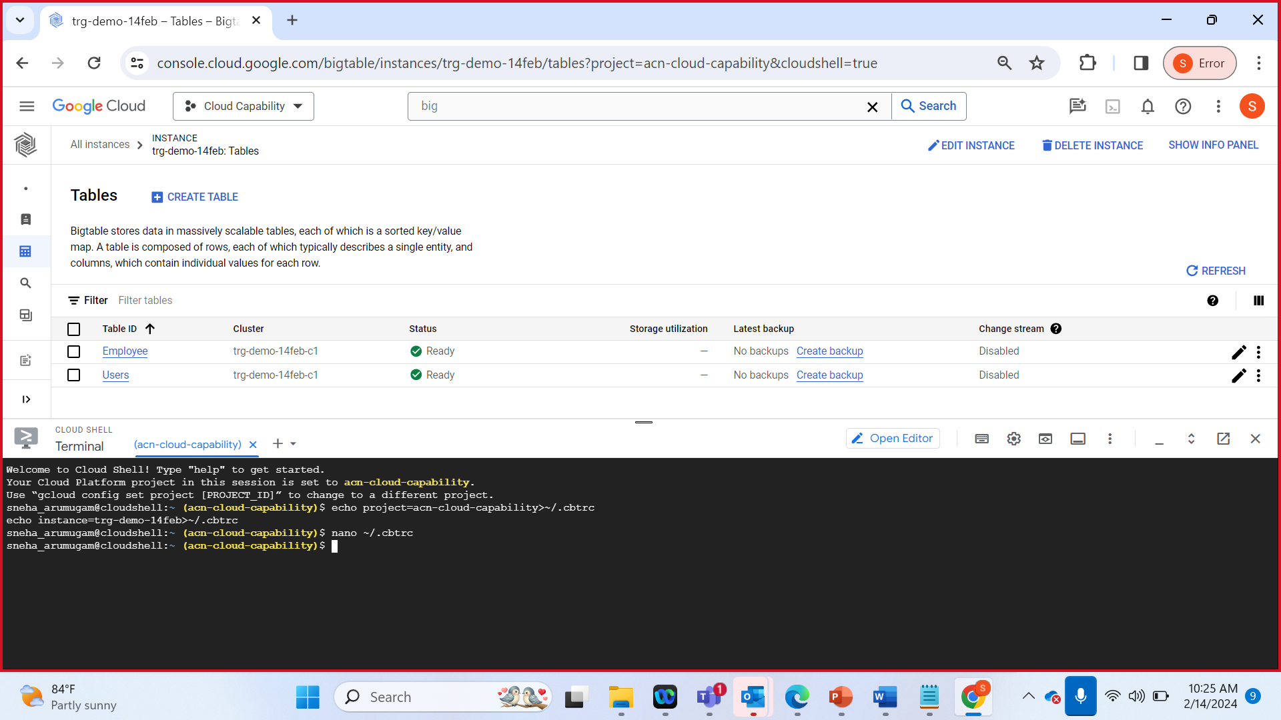

cbt createtable mytable

cbt ls

cbt createfamily mytable perdata

cbt ls mytable

cbt set mytable row1 perdata:phone=23456

cbt read mytable

10. Like wise execute the below commands in cloud shell to add and read values from the instance

cbt set mytable row1 perdata:age=23

cbt read mytable

cbt createfamily mytable ofcdata

cbt set mytable row1 ofcdata:empnum=1001

cbt read mytable

cbt set mytable row1 ofcdata:emailid=abc@acc.com

cbt read mytable

11.Using count command you can display the number of rows and using delete command you can delete the rows and table

cbt count mytable

cbt deleterow mytable row1

cbt count mytable

cbt deletetable mytable